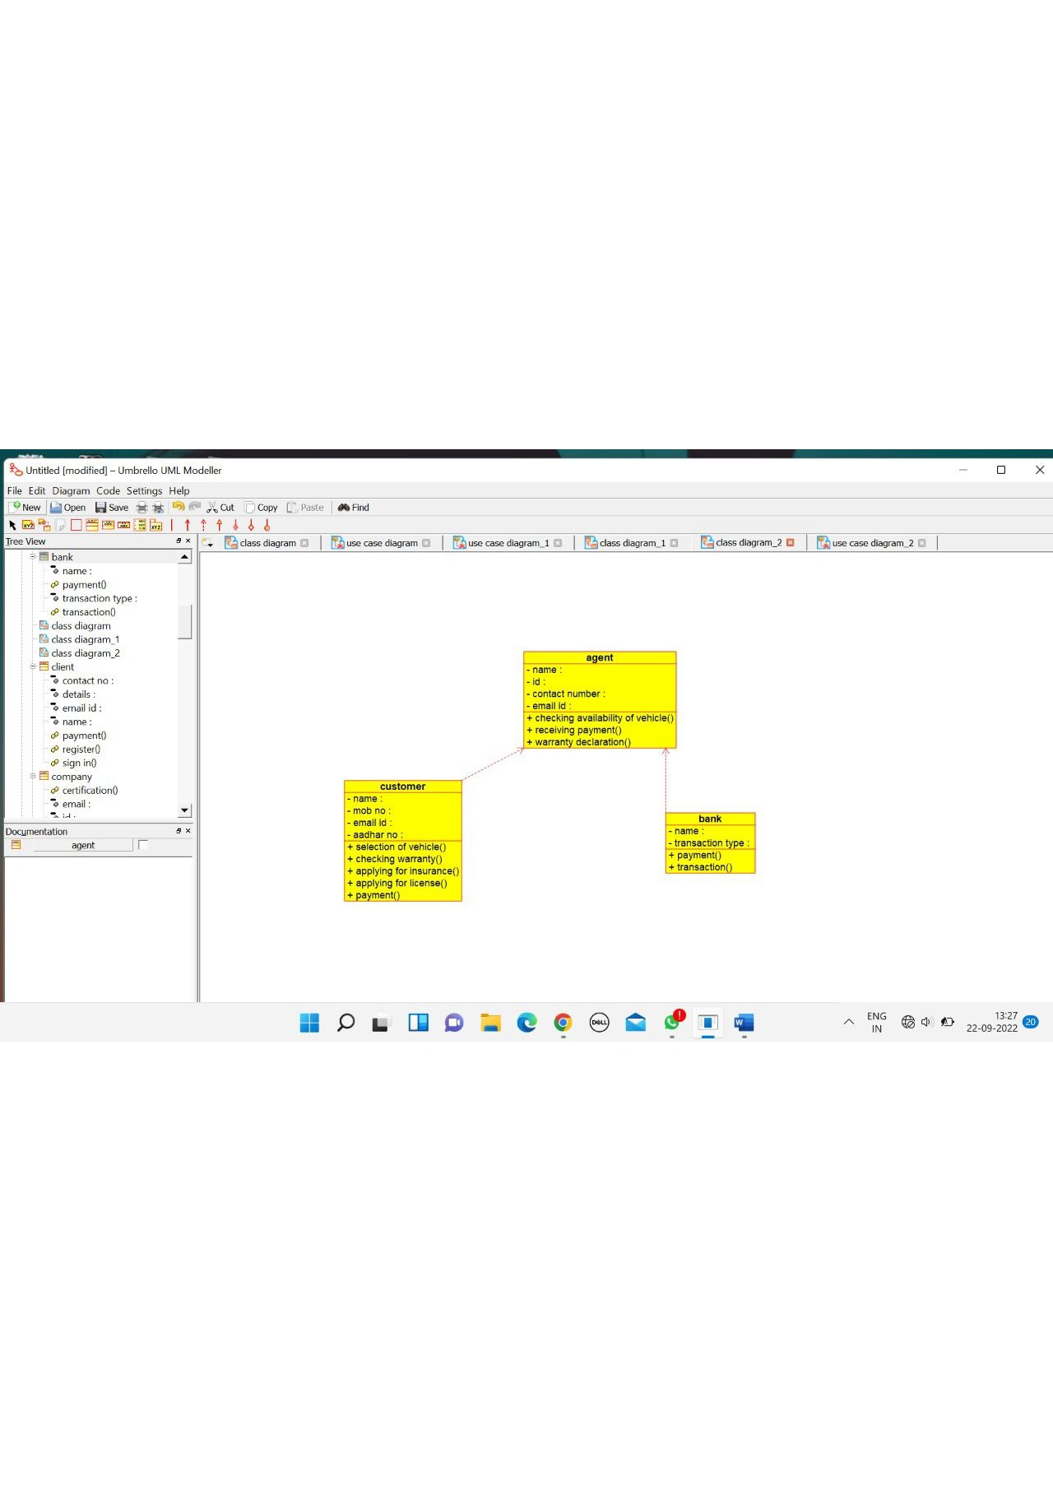

AGENT

/**

* Class agent

*/

public class agent {

//

// Fields

//

private void name;

private void id;

private void contact_number;

private void email_id;

//

// Constructors

//

public agent () { };

//

// Methods

//

//

// Accessor methods

//

/**

* Set the value of name

* @param newVar the new value of name

*/

private void setName (void newVar) {

name = newVar;

}

/**

* Get the value of name

* @return the value of name

*/

private void getName () {

return name;

}

/**

* Set the value of id

* @param newVar the new value of id

*/

private void setId (void newVar) {

id = newVar;

}

/**

* Get the value of id

* @return the value of id

*/

private void getId () {

return id;

}

/**

* Set the value of contact_number

* @param newVar the new value of contact_number

*/

private void setContact_number (void newVar) {

contact_number = newVar;

}

/**

* Get the value of contact_number

* @return the value of contact_number

*/

private void getContact_number () {

return contact_number;

}

/**

* Set the value of email_id

* @param newVar the new value of email_id

*/

private void setEmail_id (void newVar) {

email_id = newVar;

}

/**

* Get the value of email_id

* @return the value of email_id

*/

private void getEmail_id () {

return email_id;

}

//

// Other methods

//

/**

*/

public void checking_availability_of_vehicle()

{

}

/**

*/

public void receiving_payment()

{

}

/**

*/

public void warranty_declaration()

{

}

}

CLIENT

/**

* Class client

*/

public class client {

//

// Fields

//

private void name;

private void contact_no;

private void email_id;

private void details;

//

// Constructors

//

public client () { };

//

// Methods

//

//

// Accessor methods

//

/**

* Set the value of name

* @param newVar the new value of name

*/

private void setName (void newVar) {

name = newVar;

}

/**

* Get the value of name

* @return the value of name

*/

private void getName () {

return name;

}

/**

* Set the value of contact_no

* @param newVar the new value of contact_no

*/

private void setContact_no (void newVar) {

contact_no = newVar;

}

/**

* Get the value of contact_no

* @return the value of contact_no

*/

private void getContact_no () {

return contact_no;

}

/**

* Set the value of email_id

* @param newVar the new value of email_id

*/

private void setEmail_id (void newVar) {

email_id = newVar;

}

/**

* Get the value of email_id

* @return the value of email_id

*/

private void getEmail_id () {

return email_id;

}

/**

* Set the value of details

* @param newVar the new value of details

*/

private void setDetails (void newVar) {

details = newVar;

}

/**

* Get the value of details

* @return the value of details

*/

private void getDetails () {

return details;

}

//

// Other methods

//

/**

*/

public void register()

{

}

/**

*/

public void payment()

{

}

/**

*/

public void sign_in()

{

}

}

BANK:

/**

* Class bank

*/

public class bank {

//

// Fields

//

private void name;

//

// Constructors

//

public bank () { };

//

// Methods

//

//

// Accessor methods

//

/**

* Set the value of name

* @param newVar the new value of name

*/

private void setName (void newVar) {

name = newVar;

}

/**

* Get the value of name

* @return the value of name

*/

private void getName () {

return name;

}

//

// Other methods

//

/**

*/

public void transasction()

{

}

/**

*/

public void refund()

{

}

}

